|  |
| --- |
| SNHU |
| Module 5.2 Assignment |
| CS-340 |

|  |
| --- |
| Shari Storlie  12-1-2024 |

Here is a screenshot of a part of AnimalShelter.py. I did submit the full file also.

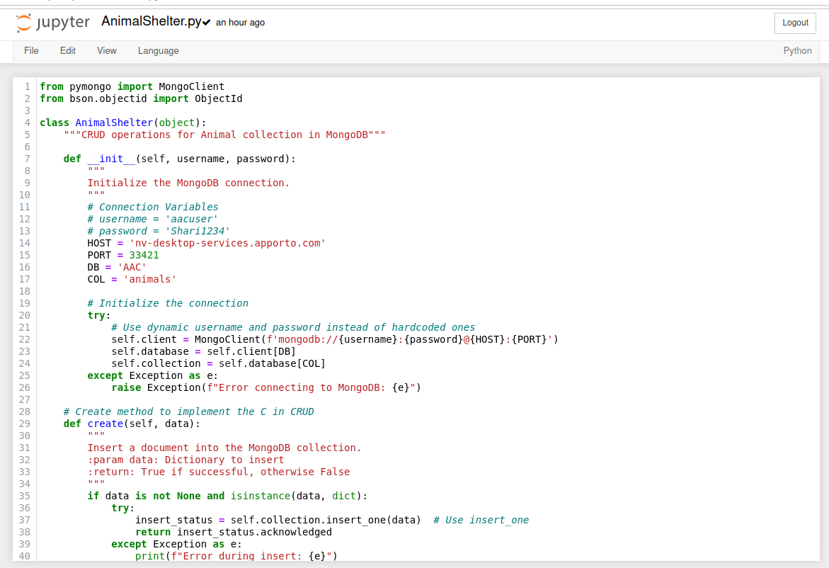

Here is a screenshot of a part of Module Five Assignment.ipynb. I did submit the full file also.

Here is the dashboard as proof of execution.

